**HOSTEL MANAGEMENT SYSTEM (HMS)**

***User Manual***

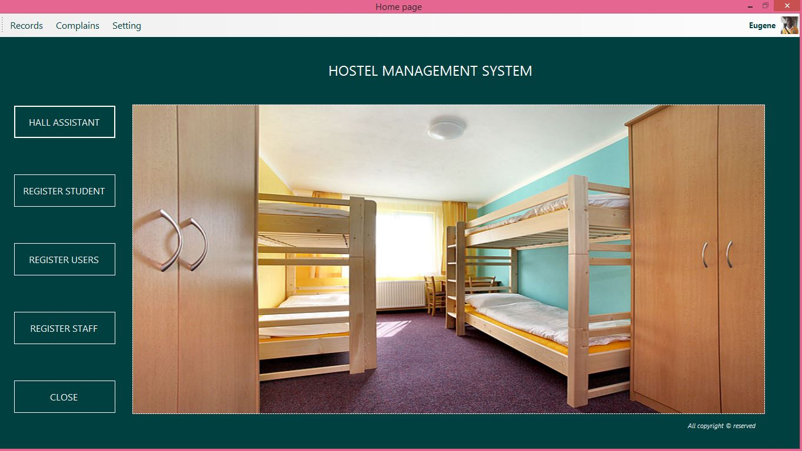

*Document Version: version 2.2*

*Document Date: May. 2017*

All rights reserved to NetFlix ©

The information in this document is confidential and may be legally privileged. If you are not the intended recipient, any disclosure, copying, distribution or any action taken or omitted to be taken in reliance on it, is prohibited and may be unlawful.

**ABSTRACT**

Hostel Management is an application developed to manage the various activities in the hostel. The software is design to deal with the problems on managing the hostel and avoids the problem occurs when carried out activities manually. Identification of the drawbacks of the existing system leads to the designing of computerized system that will be compatible to the existing system with the system which is friendlier and more Graphical User Interface (GUI) oriented. The application is capable of locating rooms automatically during registration. The application keep track of keys movement in the hostel. The application is also capable of identifying any students who brought the keys to the porters lodge (check in) and also students who came for the keys from the porters lodge (check out).

**TABLE OF CONTENT**

Introduction………………………………………………………..2

Document goals……………………………………………………2

Login (authorization) ……………………………………………...3-4

Add Records………………………………………………………..5

Search and update…………………………………………………..6

View Records………………………………………………………7

Check-out and check-in keys……………………………………….8

**General**

This document is the manual of the Hostel Management System process, designed based on instructions which are the basic guidelines and procedures for the use of the Hostel Management System application and activities to be conducted by the Hostel Management Authorities of various Institutions in Ghana.

This manual will serve as a reference and training document for the Hostel Management Authorities. Officers, operators, conductors, and all officials mandated by the Hostel Management Authorities. Of various Institutions in Ghana that benefit from this system to play a part in the computerized System exercise.

**Document Goals:**

Hostel Management Authorities intends replacing its existing manual database using computerized system. The methodology of this processes are discussed in this document and the user will be able to understand fully the usage, procedures and processes of this computerized system after reading this document.

**Procedures:**

The Hostel Management System station comes with an interactive and user friendly software which will assist the user follow through the registration process systematically and be able to acquaint himself/herself with these procedures if the guidelines in this document is followed closely.

**Processes:**

The processes of the Hostel Management system regards to records management are well captured and elaborated in this document which will help the user work precisely and efficiently, more so saving time and irregular occurrence of errors.

The final product envisaged at the end of this exercise will be a clean, duplicate free and verifiable Hostel Management database.

**Authorization:**

The Hostel Management system software can be used simultaneously by multiple users via networking. The system provide different platform for different users. Below are the types of users that will be discussed in this user manual:

* The Administrator
* The porters (Hall Assistant)

A user’s credentials determine their task and responsibilities.

**Login**

To login, locate the shortcut of the HMS link with a logo on the desktop (**HMS APP**) as shown below and double click to launch the application.



If the application launches successfully, the screen below will be displayed. Type in your ***user Id*** and ***password*** accordingly and click **[Login].**

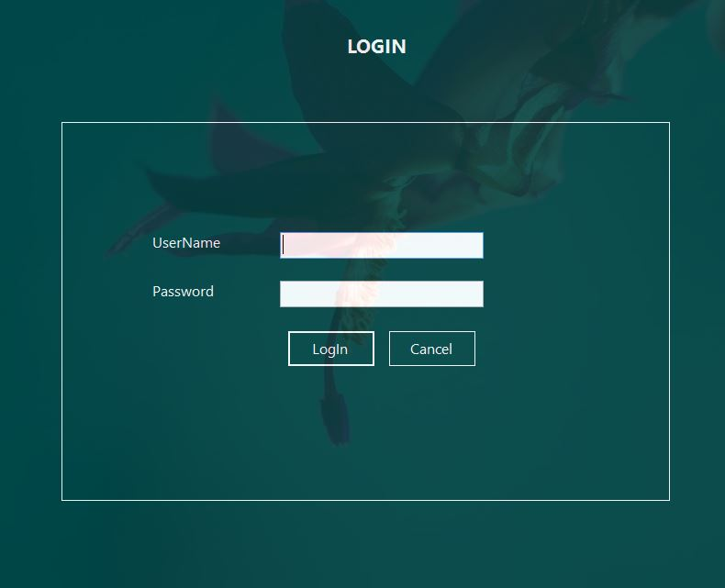

After a successful login the main page will be displayed as shown below with the following menu.

* Hall Assistant
* Register student
* Register staff
* Register user
* Records
* Complains
* Setting
* Closed
* Logout



**Add Records:**

To register student, click on the *register student* button on the home page above. When you click on the button a form will pop up as showed below. Input all the attribute of the students. Upload student passport picture and click on the save button. If records are saved, a message will popup indicating the records have been save otherwise you have to check out your input.

NB: the same procedure is applied when adding other records.

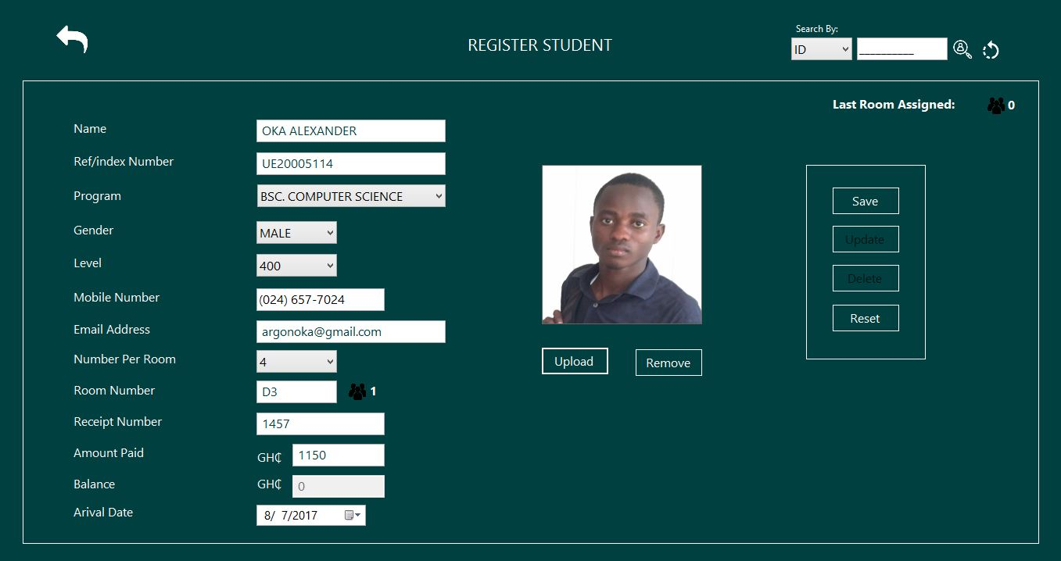

With respect to the room numbers, the system automatically allocate room for student base on the gender or level. The users have the authority to change the room number if the suggested room is not what the user want.

**Search and update student records:**

To search for students records, click on the register button and check out on the left side of the form below. One can search for student record using student telephone or ID number. Quickly select your search mode using the drop down menu at the left corner of the interface. Enter the index number of an existing student if only you selected ID else input phone number of existing student and click on the search button (the white image). The records of the existing student will pop up as showed below. If you want to delete or update a record, after searching for the desire record, click on the delete or the update button and a dialog will popup. Click on “yes” button and the record will be deleted or updated otherwise click on the “no” button.

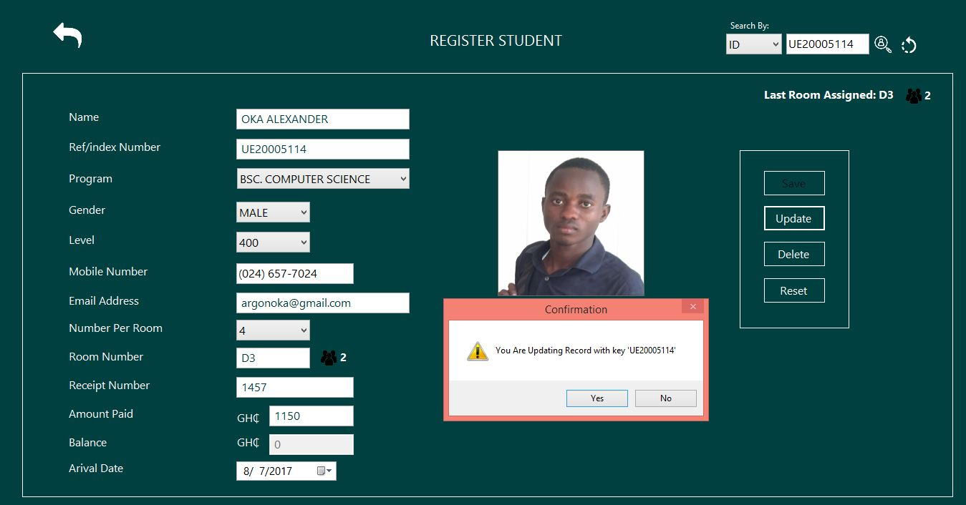

**View records:**

To view records, click on “record” at the left side of the home page. A drop down pop up showing the various type of records (student, staff, users and key log). Select and click the record of your choice and all the records will display as how below

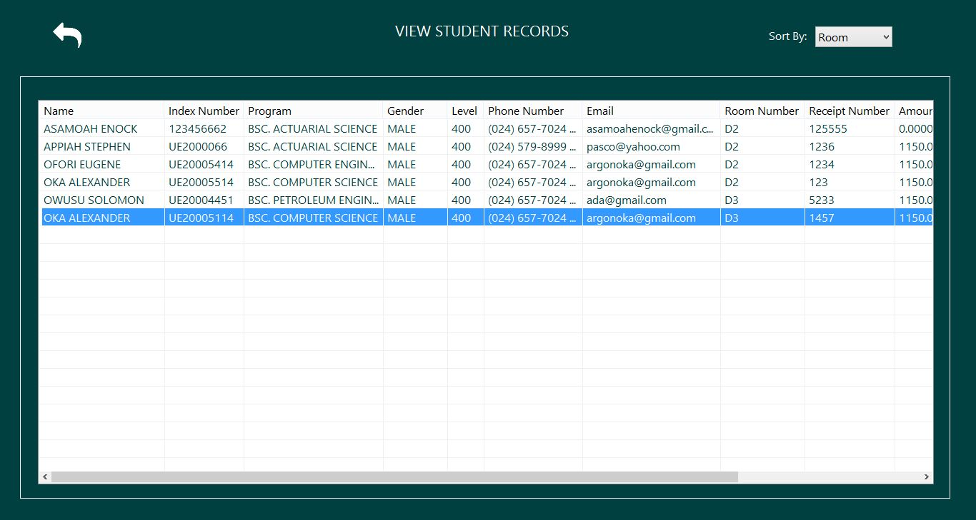

After the records has been display, you can short the records base on room number or gender. The default record displayed is shorted base on room number. Click on the “sort by” to sort records of your choice. The same procedure is applied to other records i.e. staff, user and key log records.

**Keys check-In and check-Out:**

If a student is coming for keys at the porters lodge, it consider as *“key check out”* else if a student is submitting the keys is considers as*” key check in “.* To check out or check in keys, click on “*the hall assistant button”* on the home page. Search by room or telephone number of the particular student who is bring or coming for the keys and click the search button (the white image). If you search using room number, all the four student in that particular room will display with their passport side picture as showed below else only one student record will display.

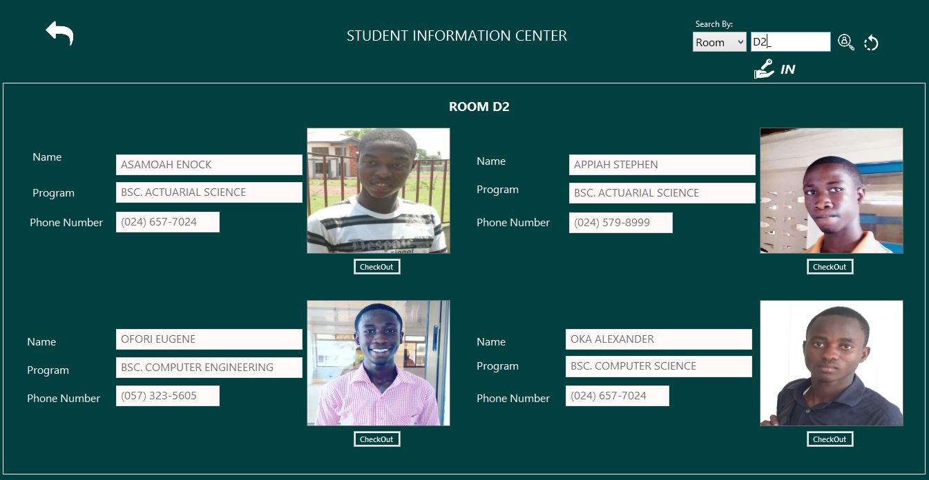

Below students’ passport pictures as show above, there is a check out and check in button. If you see check out button, it means the key is available with the porters. Click on the checkout button with respect to the particular student who is coming for the keys and give out the keys to the student.